|  |  |
| --- | --- |
| cetlogo ***CHEMICAL ENGINEERING TRANSACTIONS***  ***VOL. 92, 2022*** | A publication of  aidiclogo_grande |
| The Italian Association  of Chemical Engineering  Online at www.cetjournal.it |
| Guest Editors: Rubens Maciel Filho, Eliseo Ranzi, Leonardo Tognotti  Copyright © 2022, AIDIC Servizi S.r.l. **ISBN** 978-88-95608-90-7; **ISSN** 2283-9216 | |

Characterization of Liquid Products from Slow Pyrolysis of Woody Biomass

Liang Wanga,\*, Zsuzsanna Czégényb, Roman Tschentscherc, Øyvind Skreiberga

a SINTEF Energy Research, Sem Sælands vei 11, NO-7034 Trondheim, Norway

b Institute of Materials and Environmental Chemistry, Research Centre for Natural Sciences, Magyar tudósok körútja 2, Budapest, H-1117, Hungary

c SINTEF Industry, Forskningsveien 1, 0373 Oslo, Norway

liang.wang@sintef.no

In the present work, birch and spruce woodchips were pyrolyzed in a fixed bed reactor under different pyrolysis conditions. The effects of pyrolysis temperature and atmosphere (i.e., with and without gas purging) on yield and chemical composition of liquid products were investigated. The liquid products from the pyrolysis experiments were condensed, collected and analysed by using a gas chromatograph equipped with a mass spectrometer (GC/MS). The results showed that the yields of liquid products from pyrolysis of birch and spruce wood were different upon changes of pyrolysis temperature, purge gas flow rate and the different initial fuel chemical compositions. Higher yield of liquid products was obtained from pyrolysis of the birch wood at higher temperature or with purging of N2. The organic composition of liquid products from pyrolysis of spruce and birch wood is dominated by acetic acid, levoglucosan, and oxygenated aromatic compounds consisting mainly of phenol and phenol derivatives. Change of pyrolysis conditions caused changes in the chemical composition of liquid products from pyrolysis of birch wood. The chemical composition of liquid products from pyrolysis of birch and spruce wood are different, which is mainly related to different chemical composition of these two kinds of wood, being respectively hardwood and softwood.

* 1. Introduction

Exploitation and utilization of biomass is a highly promising way for displacing fossil fuel use and increasing sustainability of societal and industrial sectors, while combating global climate changes at the same time. Metal production is a carbon and energy intensive process, which consumes large amounts of fossil-based materials with significant emissions of CO2 (Wang et al. 2016). Biocarbon is a promising alternative to fossil reductants that are currently being used in metal production industries. To produce biocarbon for metal production purpose, slow pyrolysis at intermediate temperatures (i.e., 500-700°C) is currently a main technology applied to maximize solid yield and carbon content of solid product (Babinszki et al. 2021b). In addition to solid biocarbon, significant amounts of liquid and gaseous products are generated during pyrolysis of biomass. The yield and properties of the three main products from biomass pyrolysis depends on the pyrolysis technology and conditions, feedstock types and pre-treatment regimes, etc. At intermediate temperatures, biomass slow pyrolysis typically yields 25–35 wt% of solid char and 30–50 wt% of liquid product (Barta-Rajnai et al. 2016). The solid, biocarbon, is normally the primary target product of the slow pyrolysis. For attaining and improving the yield of biocarbon, different measures have been studied and tested including manipulating pyrolysis conditions and using biomass materials with preferred physiochemical properties (Babinszki et al. 2021a; Van Wesenbeeck et al. 2016). It consequently affects both yield and composition of the liquid and gaseous products from the slow pyrolysis of biomasses. Yield, composition and physicochemical properties of liquid product from slow pyrolysis of biomasses are affected by feedstock properties, operational conditions, liquid recovery system and type of reactor. The liquid products from pyrolysis of various biomass sources can be considerably different in terms of yield and chemical composition. Such differences and variations are directly related to the proportion between the three main components, cellulose, hemicellulose and lignin, in the biomass material and their conversion chemistry. Considering woody biomass, hardwoods contain generally 40–50 wt % cellulose, 30–35 wt % hemicellulose, 20–25 wt % lignin, and <5 wt % extractives. Whereas softwood contains on average 8 wt% more lignin and 3 wt % less hemicellulose (Fagernäs et al. 2012). For the softwood, coniferyl alcohol monomeric unit derivatives are predominant of lignin. Whereas the lignin in hardwood is normally type GS or guaiacyl-syringyl, which has derivatives from syringyl alcohol and coniferyl alcohol monomeric units as main compositions (Fagernäs et al. 2012). Upon different pyrolysis conditions, the three main components with different chemical compositions in softwood and hardwood will undergo different reactions leading to formation of liquid products with various physiochemical properties. During pyrolysis of biomass, primary and secondary reactions involving heat and mass transfer mechanisms take place. The primary reactions generally include decomposition of cellulose, hemicellulose and lignin in biomass, leading to formation of primary and intermediate products. The primary reactions include dehydration and charring reactions, while the secondary reactions include cracking, decomposition and volatilization of intermediates. The primary and secondary reactions can occur in parallel and compete, and are sensitive to pyrolysis process parameters and biomass type. As one of these parameters, pyrolysis temperature plays a critical role regarding decomposition of biomass materials. In general, the liquid products from biomass pyrolysis reach a maximum in the temperature range 400–550 °C and decrease with further increase of pyrolysis temperature, as the secondary reactions and decompositions dominate, causing enhancement of gas yield at the expense of char and liquid product yields (Akhtar and Saidina Amin 2012). Residence time of vapour is the other factor that considerably affects yield and composition of the liquid product from pyrolysis of biomass. During pyrolysis, the tarry vapours and volatiles from biomass particles are susceptible to cracking and repolymerize inside and around the particles and in the free space of the reactor as well. Pyrolysis conditions that promotes rapid mass transfer can hinder cracking and secondary reactions of tarry vapours, including vacuum pyrolysis, purging of pyrolysis vapours, rapid quenching of hot vapours and use of feedstock with small particles (Uçar and Karagöz 2009). The liquid product from slow pyrolysis of biomass is a mixture of aqueous and bio-oil phases. The aqueous phase includes mainly water (∼90 wt%) coming from the moisture of the biomass and dehydration reactions occurring during the pyrolysis process (Akhtar and Saidina Amin 2012). The aqueous phase also contains a small fraction of low molecular weight oxygenated water-soluble organic compounds such as aldehydes, ketones, alcohols, phenols and others. The bio-oil is complex mixture of aliphatic, aromatic, hydrocarbon and oxygenated compounds and their derivatives. The liquid products of biomass pyrolysis have value as fuel, which can be refined and upgraded as a substitute for fossil oil. Moreover, the liquid products can also be a source of chemicals, such as phenols and organic acids, in economically recoverable concentrations. Characterization of liquid products is therefore important to know their physiochemical properties, select upgrading measures and enable recovery and use of them for increasing profitability of the biomass pyrolysis process.

In this work, spruce softwood and birch hardwood were selected as the biomass samples for a pyrolysis study in a fixed bed reactor. The yields of liquid products from slow pyrolysis of the two feedstocks were determined at different conditions. The chemical compositions of the produced liquid products were analysed by using gas chromatography/mass spectrometry (GC/MS). The effect of pyrolysis parameters, temperature and sweep gas flow, on yields and chemical compositions of the liquid products from pyrolysis of the spruce and birch wood were investigated.

* 1. Experimental
     1. Samples

The softwood and hardwood feedstock used in this work were spruce wood (*Picea abies*) and birch wood (*Betula pubescens*) harvested from South Norway forests. The spruce and birch trees were harvested and debarked to obtain stem wood. The stem wood was chipped into pieces, and 3-5 cm large pieces were selected as feedstock for the pyrolysis experiments. The chips were then dried to approximately 15% moisture content at room temperature and were further dried in an oven at 105 °C for 24 hours before pyrolysis experiments. Moisture, ash and volatile matter content of the spruce and birch wood were determined according to ASTM standard D1762-84. Ultimate analyses of the dried woodchips were conducted by using an elemental analyzer (Eurovector EA 3000 CHNS-O Elemental Analyser). Oxygen content was calculated by difference. For each sample, triplicate analyses were conducted, and results of the analyses are presented in Table 1. The contents of carbohydrates and Klason lignin of the spruce and birch wood were determined. The dried woodchips were first milled and treated in a two-step acid hydrolysis with 2% H2SO4 for 2 h at room temperature and then with 4% H2SO4 for 1 h at 120 °C. The suspensions from the hydrolysis step were then filtered and washed with distilled water. The filter supernatants were further analysed with high-performance liquid chromatography (HPLC) using an Agilent 1260 system with a Hi-Plex H column (Agilent, Santa Clara, CA) at 65 °C. The solid residues after the washing step were collected and dried at 105 °C until reaching a constant weight, and contains acid-insoluble organics and acid-insoluble ash (Barta-Rajnai et al. 2016). The dried solid residue was heated at 550 °C for 5 h until the sample weight was constant and is considered as the content of acid-insoluble ash. The Klason lignin content was calculated by subtracting the acid-insoluble ash content from the acid-insoluble residue content. All experimental data were determined using three replicates.

* + 1. Pyrolysis

Pyrolysis experiments were carried out by using a lab-scale pyrolysis system. The system contains an electrical furnace, a stainless-steel tubular reactor, an off-gas line and a water-cooled condenser. For one pyrolysis experiment, a fixed amount of about 700 grams of woodchips was loaded in the tubular reactor that was then sealed and placed inside the furnace. The tubular reactor was then connected with the gas supply line and off-gas line. Purging gas flow is applied from the bottom of the tubular reactor to establish the desired pyrolysis environment and enabling altering of the residence time of volatiles released from biomass particles. As one experiment starts, power to the electrical furnace is turned on to heat up the tubular reactor with a desired heating rate. The temperature in the furnace is controlled and monitored by thermocouples located in the top, middle and bottom sections of the furnace. During running of one pyrolysis experiment, the volatile products leave the reactor and reach the condenser. Condensable compounds were cooled down to 5 °C and collected in a metal tank below the condenser. The incondensable volatiles further flow through filters and are continuously monitored by a micro gas chromatograph (Varian Cp-4900), equipped with two injectors connected to individual columns. The column was a 10 m PoraPLOT type using high purity Helium as a carrier gas to measure CO2, CH4, C2H4 and C2H6. Before start of one experiment, the tubular reactor was first purged with 2L min-1 nitrogen to flush away air to generate inert atmosphere before increase of temperature. After the experiment, the power to the furnace is turned off and the reactor was cooled down to room temperature. The solid biocarbon was collected and weighed. The condensable products collected in the metal tank and trapped in the connected tubing components were weighed and considered as liquid product.

The pyrolysis experiments were conducted in two different atmospheres, including static (without using purging gas) and with purging of nitrogen in the fixed bed reactor. For static atmosphere experiments, the woodchips were first loaded in the reactor that was purged with nitrogen and then the sweeping gas flow was cut off as an experiment starts. The temperature was raised at 10 K min-1 heating rate to a final temperature of 400, 500 and 700 °C to study the effect of final temperature on the yield and composition of the liquid products. As the highest heating temperature was reached, the experiment was continued for an additional 60 min to ensure complete conversion of the sample. For the experiment performed under nitrogen atmosphere, the sweep gas flow rate was set to 2 L min-1,which limits the residence time of tarry vapours and volatiles and consequently secondary reactions of them.

* + 1. Characterization of liquid products

The obtained condensates were filtered through a cellulose filter. For the GC/MS analysis a 5% solution was prepared with acetone solvent. Anisole at a concentration of 300 ppm was selected as internal standard. The GC/MS analysis of the condensates was performed by an Agilent 7890A/5977B GC/MS system (Agilent Technologies, USA) equipped with an Agilent DB-1701 capillary column (30 m × 0.25 mm i.d., 0.25 µm film thickness). 1 μL solution was injected into the injector heated at 280 °C in split mode. The helium carrier gas flow was 1 ml min–1. The following GC heating program was applied: 4 min isothermal period at 40 °C, then the temperature was increased at a heating rate of 6 °C min–1 to 280 °C, and was held for 5 min. The MS was operated in electron ionization (EI) mode at 70 eV and the mass range of 14–550 m/z was scanned. Each sample was measured in triplicates. The components of the condensates were identified based on their mass spectra using the combined Wiley Registry 9th edition and NIST 2011 mass spectral libraries. The spectral identity of the compounds was more than 90% for all identified components.

* 1. Results and discussion
     1. Yield of liquid products

As shown in Table 1, the general properties like proximate analysis results and elemental composition of spruce wood are similar to those of birch wood. However, the lignin content of spruce wood is about 31.13%, that is 10.64 percentage points higher than that of birch wood. Additionally, contents of cellulose and hemicellulose in spruce wood are also different than that of birch wood. Figure 1 shows the yield of liquid products from the studied spruce and birch wood under different conditions. It can be seen that temperature affects the yield of products. The yield of liquid products from pyrolysis of birch wood increased from 58.45% to 59.79% when increasing the temperature from 400 to 500 °C, which increased further to 60.23% at a temperature of 700 °C. At low temperature, degradation of biomass mainly takes place at heteroatom sites within the biomass structure, leading to formation of heavy tars. While at high temperature (>500 °C), more intensive decomposition of biomass and cracking of intermediate products results in a wider range of compounds. There is a tradeoff between high biomass conversion degree and the degree of secondary decomposition of liquid products during pyrolysis of biomass materials. At a high pyrolysis temperature, increase of gas yields has been generally reported, which is related to further devolatilisation of the char and cracking of tarry vapors at a higher pyrolysis temperature. It is noticeable that a higher yield of liquid product was obtained from the experiment with purging of N2 as carrier gas. The influence of purge gas flow rate on pyrolysis products distribution has been studied earlier. It was reported that the yields of liquid products from pyrolysis of pomegranate seeds in a fixed bed reactor was decreased by lowering the purging N2 flow rate (Uçar and Karagöz 2009). During pyrolysis of biomass, secondary reactions of volatiles and tarry vapors around solid charring particles and in the free zone of reactor might occur. The extents of these reactions are closely related to pyrolysis temperature and residence time of pyrolysis vapors. The inert purging gas generates nonreactive atmosphere and removes the pyrolysis products from the hot zone in the reactor. Using N2 gas flow will dilute and push out the hot pyrolysis vapors and reduce the residence time of them, restricting decomposition related to cracking, polymerization and condensation. Consequently, larger amounts of tarry vapors will leave the reactor, which can be further condensed and collected as liquid products.

As shown in Figure 1, liquid products obtained from pyrolysis of spruce wood yield 57.95%, while birch wood yields 59.79%, at 500 °C. Variations of bio-oil yield from pyrolysis of different biomasses have been frequently reported, which are often directly related to the content and type of chemical compositions of biomasses. Garcìa-Pérez et al. conducted pyrolysis of softwood bark and hardwood bark and obtained yields of 45.0% and 53.9% respectively (Garcìa-Pérez et al. 2007). The difference in liquid product yields is partially explained due to higher content of lignin in softwood bark and higher contents of hemicellulose/cellulose in hardwood bark (Garcìa-Pérez et al. 2007). However, such differences can vary upon reaction conditions and process parameters.

Table 1: Main characteristics of spruce and birch wood

|  |  |  |  |  |
| --- | --- | --- | --- | --- |
|  |  | Spruce wood |  | Birch wood |
| Proximate analysis (dry basis,wt%) |  |  |  |  |
| Volatile matter |  | 83.76±0.05 |  | 84.43±0.05 |
| Ash |  | 0.67±0.05 |  | 0.78±0.05 |
| Fixed carbona |  | 15.57 |  | 14.79 |
| Ultimate analysis (dry ash free basis,wt%) |  |  |  |  |
| C |  | 49.50±0.25 |  | 47.2±0.24 |
| H |  | 6.07±0.11 |  | 6.01±0.13 |
| N |  | 0.15±0.01 |  | 0.13±0.01 |
| S |  | 0.03±0.005 |  | 0.02±0.005 |
| Oa |  | 44.25 |  | 46.64 |
| Compositional analysis (dry basis, wt%) |  |  |  |  |
| Cellulose |  | 40.14±0.54 |  | 38.62±0.19 |
| Hemicellulose |  | 20.34±0.07 |  | 24.18±0.12 |
| Klason lignin |  | 31.13±0.50 |  | 19.49±0.07 |
| Insoluble ash |  | 0.35±0.01 |  | 0.44±0.01 |
| Other |  | 8.04±0.74 |  | 17.28±0.24 |

a: calculated by difference

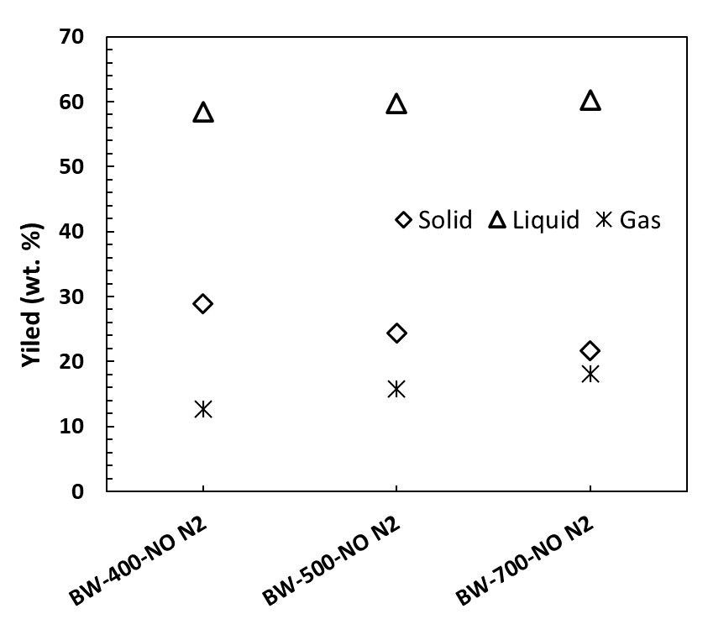 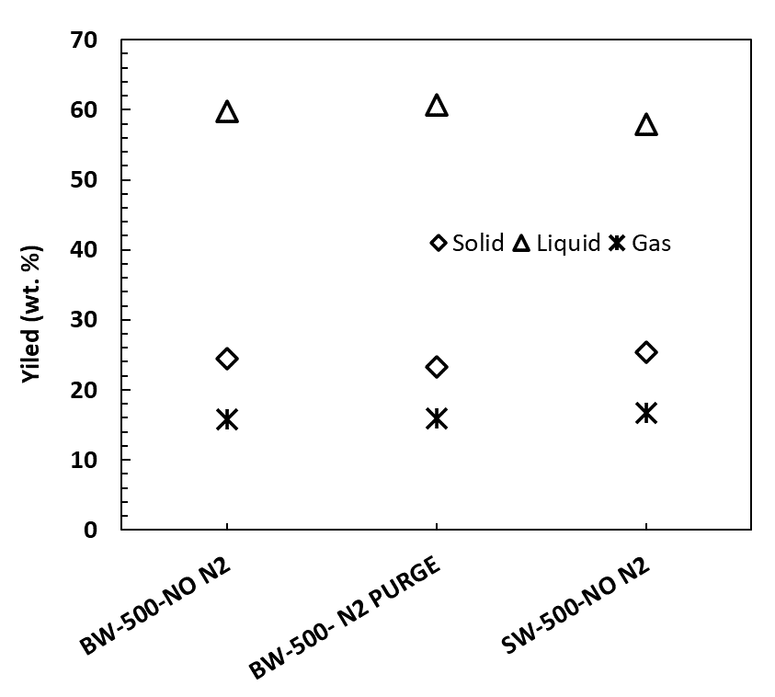

*Figure 1: Effect of pyrolysis conditions on product yields from birch wood (BW) and spruce wood (SW).*

* + 1. Analysis of liquid product

The composition of the condensed liquid product was analysed by GC/MS. The GC/MS chromatograms of the condensates collected after pyrolysis experiments at 400, 500 and 700°C are presented in Figure 2. The main components are decomposition products of the biopolymer components of the birch wood.

The pattern of the obtained chromatograms is almost identical, indicating that the composition of the condensates prepared at different final temperatures are very similar. Most probably, the main thermal decomposition process takes place during the gradual heating period of the experiment in the temperature range of 300-400°C. The vast majority of the condensable products is formed during this step. At higher temperatures further carbonization processes take place, releasing mostly lower molecular weight gaseous products like CO, CH4 and CO2, which does not modify the composition of the condensate significantly.

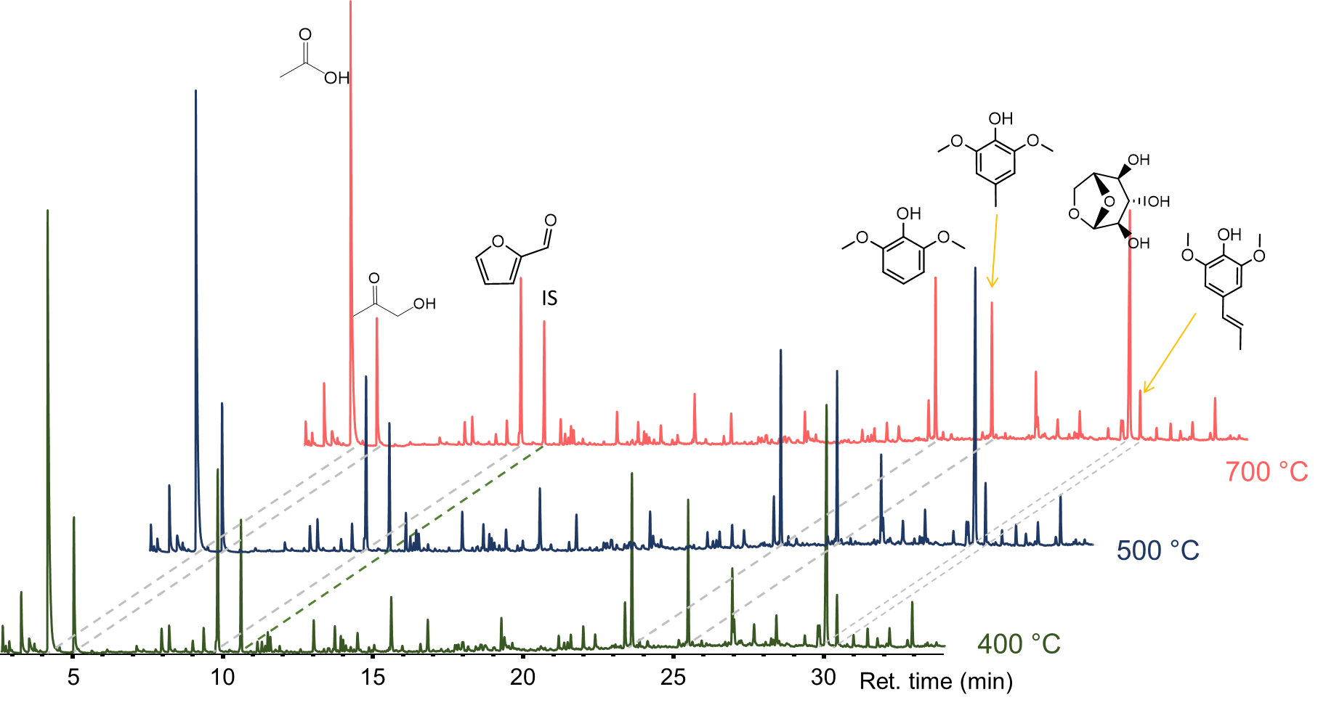

*Figure 2: GC/MS total ion chromatograms of birch condensates produced at 400, 500 and 700°C. (IS: internal standard)*

**

Figure 3: GC/MS total ion chromatograms of birch and spruce condensates produced at 500°C pyrolysis temperature.

Figure 3 presents the GC/MS chromatograms of the birch and spruce condensates, both produced at 500 °C final temperature. The different pattern of the chromatograms indicates the different composition of the condensates. Birch represents a hardwood, while spruce is a softwood. The different chemical composition of the two types of wood is reflected in the composition of their condensates. The birch condensate contains a large amount of acetic acid, formed mostly by the deacetylation of the O-acetyl-4-O-methyl glucuronoxylan type hemicellulose of the birch. The main building blocks of the spruce hemicellulose are galactoglucomannan and arabinoglucuronoxylan, which does not produce a high amount of acetic acid during thermal decomposition, Therefore, the difference in hemicellulose composition is reflected in the acetic acid content of the condensates. Other degradation products of the carbohydrate biopolymers (cellulose and hemicellulose) like furan and pyran derivatives, anhydrosugars (e.g. levoglucosan) are presented in both condensates in similar amounts. Regarding the lignin decomposition products, significant differences can be observed. The softwoods lignin (spruce) yields guaiacyl derivatives, while hardwood lignin (birch) decomposes to both syringil and guaiacyl derivatives. The thermal decomposition products reflect the lignin composition, where spruce contains G-lignin, while birch contains both S- and G-lignin.

* 1. Conclusions

In the current study, slow pyrolysis of spruce and birch woodchips were conducted in a fixed bed reactor with collection of liquid products. The effects of pyrolysis temperature and purging of gas on yield and composition of liquid products were studied. The results showed that pyrolysis temperature and purging gas flow affected the yield of liquid products. A lower yield of liquid products was produced from the pyrolysis of birch wood without purging of gas. It can be related to longer residence time of tarry vapors in the reactor, which implies a higher tendency to involve in secondary reactions and convert to non-condensable gases. Different liquid product yields were also obtained from pyrolysis of the spruce and birch wood, which can be mainly attributed to differences in chemical compositions of them. For the birch wood, the composition of the condensates does not change significantly with the pyrolysis temperature at the 400, 500 and 700oC used in the current work. The composition of the condensed liquid product is basically determined by the feedstock, with considering the different chemical composition of birch and spruce wood.

Acknowledgments

This work was supported by the Research Council of Norway and a number of industrial partners through the project BioCarbUp (Grant No. 294679/E20).

References

Akhtar J., and NorAishah S.A., 2012, A Review on Operating Parameters for Optimum Liquid Oil Yield in Biomass Pyrolysis. Renewable and Sustainable Energy Reviews,16, 5101–9.

Babinszki B., Z Sebestyén., E Jakab., L. Kőhalmi., J Bozi., G. Várhegyi., L. Wang., Ø. Skreiberg., and Z. Czégény, 2021, Effect of Slow Pyrolysis Conditions on Biocarbon Yield and Properties: Characterization of the Volatiles. Bioresource Technology, 338,125567.

Eszter B-R., Jakab E., Sebestyén Z., May Z., Barta Z., Wang L., Skreiberg Ø., Grønli M., Bozi János., and Czégény Z, 2016, Comprehensive Compositional Study of Torrefied Wood and Herbaceous Materials by Chemical Analysis and Thermoanalytical Methods, Energy & Fuels, 30, 8019–30.

Fagernäs L., Eeva K., Kari T., and Anja Oasmaa., 2012, Chemical Composition of Birch Wood Slow Pyrolysis Products, Energy & Fuels, 26, 1275–83.

Garcìa-Pérez M., Chaala A., Pakdel H., Kretschmer D., and Roy C, 2007, Vacuum Pyrolysis of Softwood and Hardwood Biomass: Comparison between Product Yields and Bio-Oil Properties, Journal of Analytical and Applied Pyrolysis, 78,104–16.

Uçar S., and Selhan K, 2009, The Slow Pyrolysis of Pomegranate Seeds: The Effect of Temperature on the Product Yields and Bio-Oil Properties.” Journal of Analytical and Applied Pyrolysis, 84, 151–56.

Sam V. W., Wang L., Ronsse F., W. Prins., Skreiberg O., and Antal M.J., 2016, Charcoal ‘Mines’ in the Norwegian Woods. Energy and Fuels, 30, 7959–70.

Wang, L., B. Hovd, Bui H.-H., Valderhaug A., Buø T.V., Birkeland R.G., Skreiberg Ø., and Tran K.-Q., 2016, CO2 Reactivity Assessment of Woody Biomass Biocarbons for Metallurgical Purposes, Chemical Engineering Transactions 50: 55–60.